**Challenge #2**

We need to write code that will query the meta data of an instance within AWS or Azure or GCP and provide a json formatted output.   
The choice of language and implementation is up to you.

**Bonus Points**

The code allows for a particular data key to be retrieved individually

Hints

·         Aws Documentation (<https://docs.aws.amazon.com/>)

·         Azure Documentation (<https://docs.microsoft.com/en-us/azure/?product=featured>)

·         Google Documentation (<https://cloud.google.com/docs>)

**Azure Portal: Azure Instance Metadata Service**

I have written Terraform Module for create a Azure virtual machine on Azure portal.

1. Root terraforms module
2. Child terraform module
3. A Terraform module can call other modules to add their resources to the configuration.

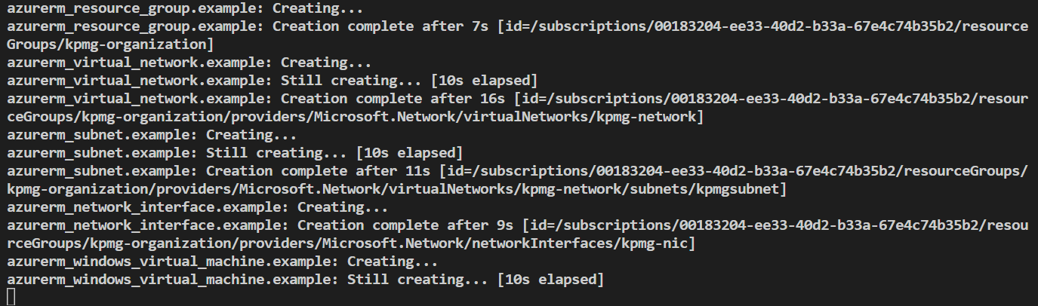

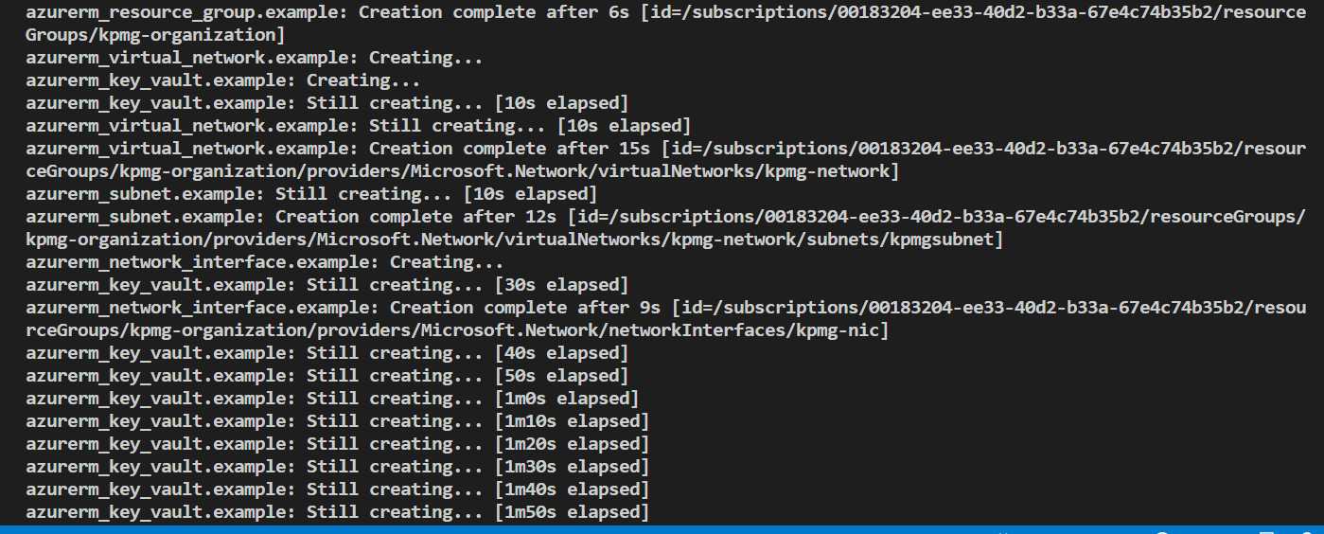

**Infra got created**

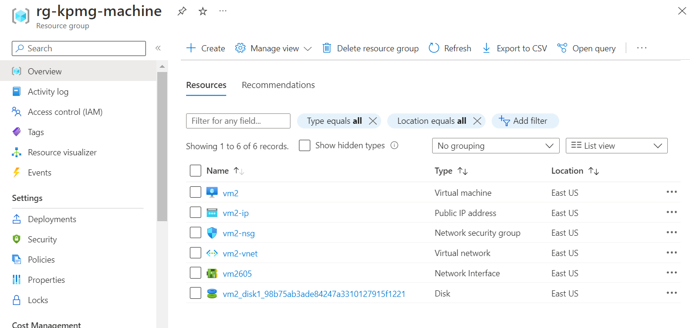

**Azure Virtual Machine:**

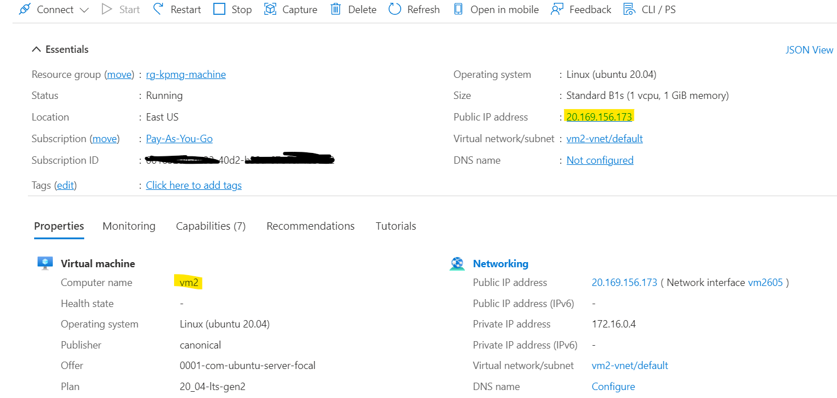

Login to Virtual Machine through putty using vm IP address

Update the vm machine after logged in to machine.

* sudo apt-get update
* sudo apt-get install jq
* curl -s -H Metadata:true --noproxy "*" "http://169.254.169.254/metadata/instance?api-version=2021-02-01" | jq

Queried the meta data of an azure vm instance within Azure and provided a json formatted output.

Please find the below snapshots.

In **json** file contains the **sku**, **storage**, **network configuration** information etc.

1)

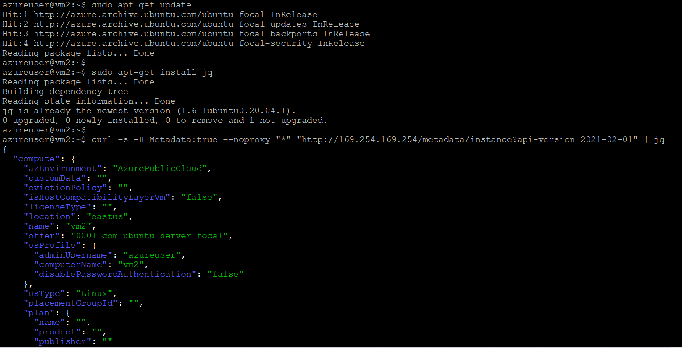

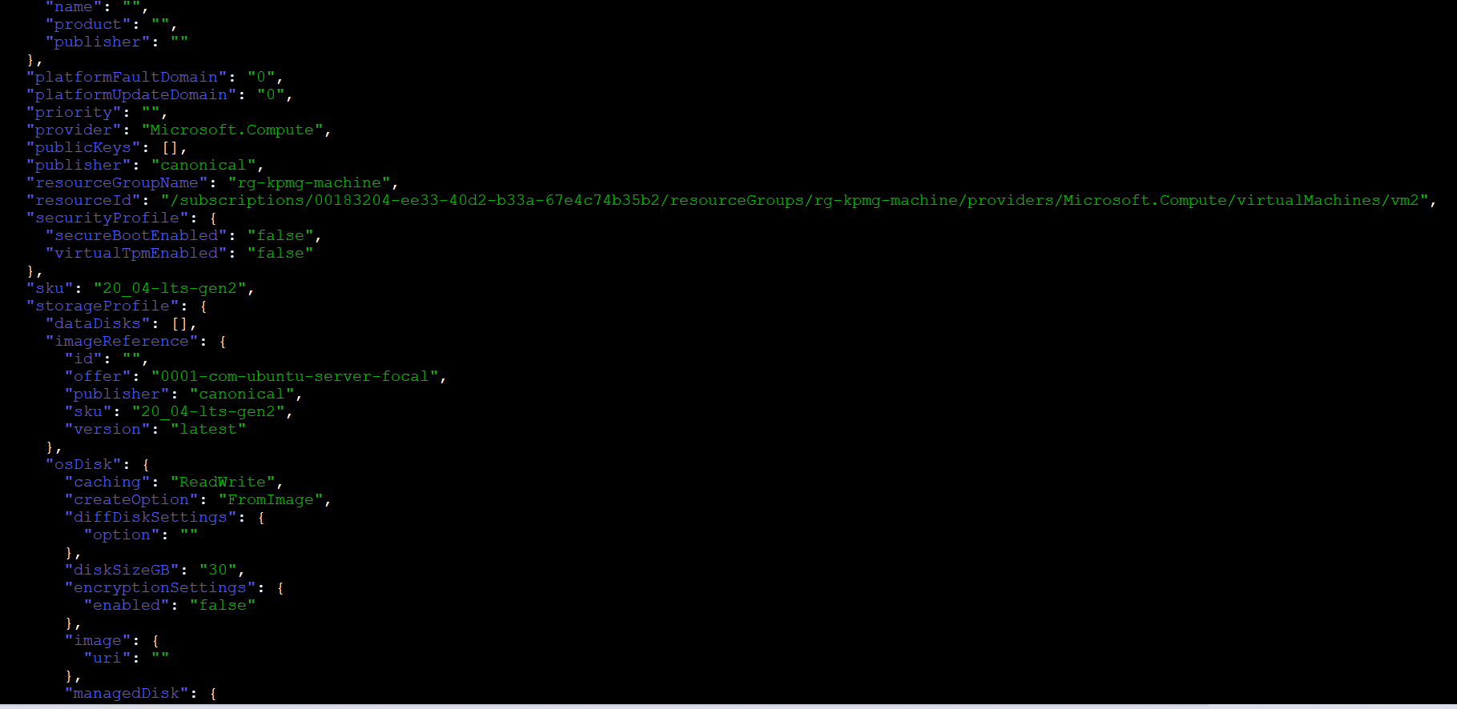

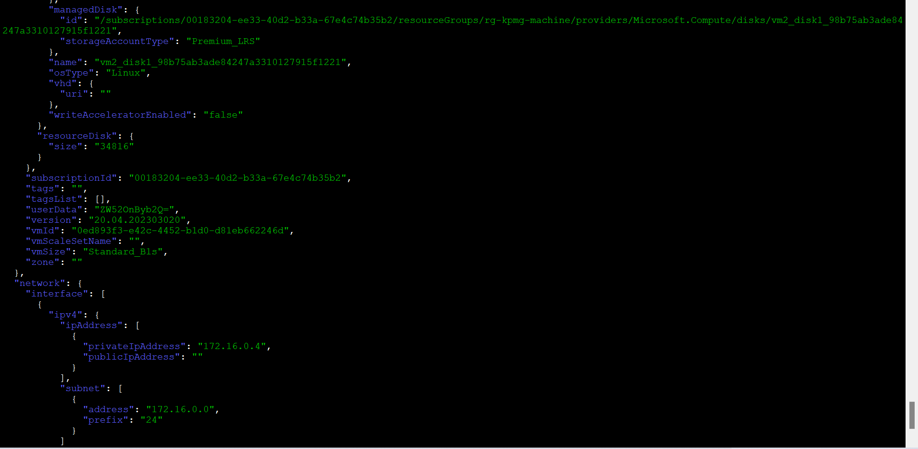

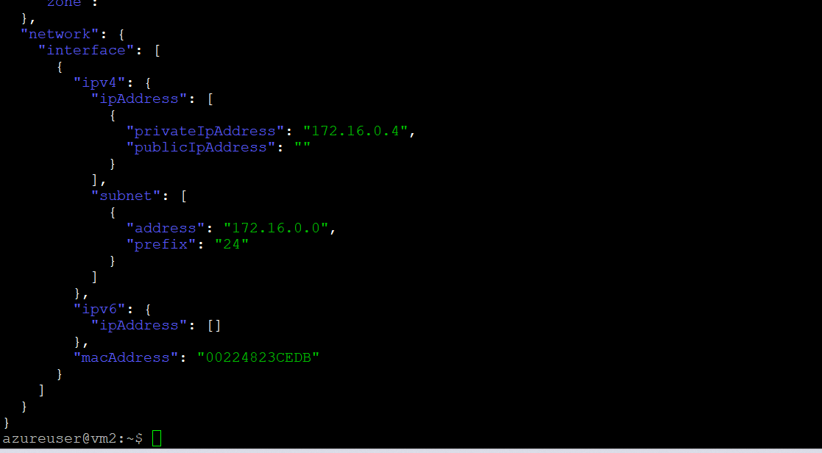

2)

Json format: -

azureuser@vm2:~$ curl -s -H Metadata:true --noproxy "*" "http://169.254.169.254/metadata/instance?api-version=2021-02-01" | jq

{

  "compute": {

    "azEnvironment": "AzurePublicCloud",

    "customData": "",

    "evictionPolicy": "",

    "isHostCompatibilityLayerVm": "false",

    "licenseType": "",

    "location": "eastus",

    "name": "vm2",

    "offer": "0001-com-ubuntu-server-focal",

    "osProfile": {

      "adminUsername": "azureuser",

      "computerName": "vm2",

      "disablePasswordAuthentication": "false"

    },

    "osType": "Linux",

    "placementGroupId": "",

    "plan": {

      "name": "",

      "product": "",

      "publisher": ""

    },

    "platformFaultDomain": "0",

    "platformUpdateDomain": "0",

    "priority": "",

    "provider": "Microsoft.Compute",

    "publicKeys": [],

    "publisher": "canonical",

    "resourceGroupName": "rg-kpmg-machine",

    "resourceId": "/subscriptions/00183204-ee33-40d2-b33a-67e4c74b35b2/resourceGroups/rg-kpmg-machine/providers/Microsoft.Compute/virtualMachines/vm2",

    "securityProfile": {

      "secureBootEnabled": "false",

      "virtualTpmEnabled": "false"

    },

    "sku": "20_04-lts-gen2",

    "storageProfile": {

      "dataDisks": [],

      "imageReference": {

        "id": "",

        "offer": "0001-com-ubuntu-server-focal",

        "publisher": "canonical",

        "sku": "20_04-lts-gen2",

        "version": "latest"

      },

      "osDisk": {

        "caching": "ReadWrite",

        "createOption": "FromImage",

        "diffDiskSettings": {

          "option": ""

        },

        "diskSizeGB": "30",

        "encryptionSettings": {

          "enabled": "false"

        },

        "image": {

          "uri": ""

        },

        "managedDisk": {

          "id": "/subscriptions/00183204-ee33-40d2-b33a-67e4c74b35b2/resourceGroups/rg-kpmg-machine/providers/Microsoft.Compute/disks/vm2_disk1_98b75ab3ade84247a3310127915f1221",

          "storageAccountType": "Premium_LRS"

        },

        "name": "vm2_disk1_98b75ab3ade84247a3310127915f1221",

        "osType": "Linux",

        "vhd": {

          "uri": ""

        },

        "writeAcceleratorEnabled": "false"

      },

      "resourceDisk": {

        "size": "34816"

      }

    },

    "subscriptionId": "00183204-ee33-40d2-b33a-67e4c74b35b2",

    "tags": "",

    "tagsList": [],

    "userData": "ZW52OnByb2Q=",

    "version": "20.04.202303020",

    "vmId": "0ed893f3-e42c-4452-b1d0-d81eb662246d",

    "vmScaleSetName": "",

    "vmSize": "Standard_B1s",

    "zone": ""

  },

  "network": {

    "interface": [

      {

        "ipv4": {

          "ipAddress": [

            {

              "privateIpAddress": "172.16.0.4",

              "publicIpAddress": ""

            }

          ],

          "subnet": [

            {

              "address": "172.16.0.0",

              "prefix": "24"

            }

          ]

        },

        "ipv6": {

          "ipAddress": []

        },

        "macAddress": "00224823CEDB"

      }

    ]

  }

}

azureuser@vm2:~$